

September 24, 2009
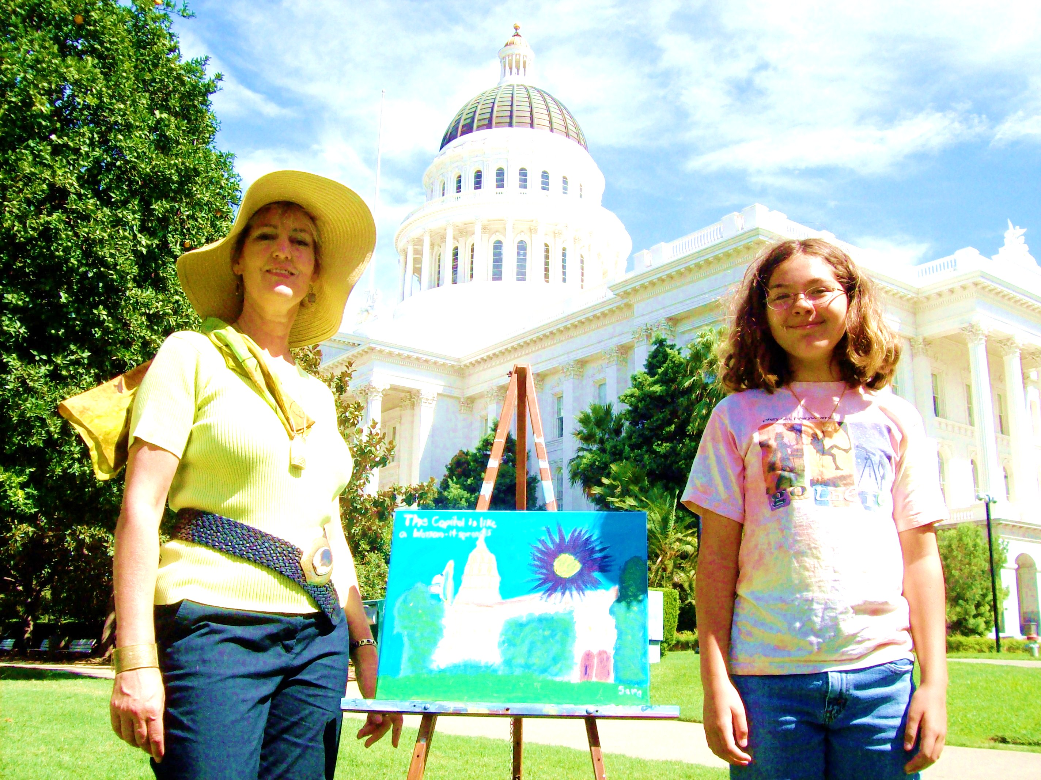

Art Tour

Artist and activist Leisa Collins stopped by Sacramento on Sept, 13 as part of a 6,000-mile tour around the U.S. She held painting lessons at the Capitol to protest the cuts to arts education in the latest California budget. She’s shown here with student Sara Benassini of Carmichael and her painting of the Capitol. Photo by Bruce Goodman.

