Rotorua Daily Post

New Zealand, Friday, December 18, 2009

Painting a house portrait

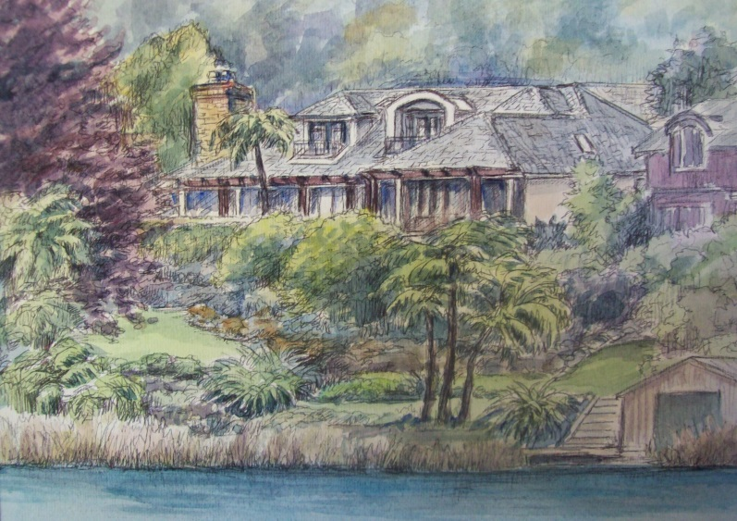
A quick stop over in Rotorua to see family
Turned into a more lengthy painting spree
for New Zealand artist Leisa Collins.
“I’ve just toured 11,000 km across America
On a painting tour and have been all over
New Zealand in the last few weeks, how-
ever Rotorua has the most beautiful lake-
Side homes I’ve ever seen!” said Leisa.
“I started selectively putting flyers into the
Letterboxes of these homes and have got
very good response.”

She has since completed a pen and watercolor wash house portrait of a Lake Okareka property on Acacia Road and is now working on other commissioned works.

Recently, Leisa was at Mt Cook as part of a tour in which she is retracing her footsteps of a journey she took through the South Island 30 years earlier. At that time she abandoned formal art training and the confines of the classroom in Auckland, opting to learn her craft through capturing on canvas the beauty of the New Zealand landscape. She celebrated her return to Mt Cook by giving an impromptu watercolor lesson to the pupils of the Aoraki Mt Cook School.

Leisa recently took up her paintbrush and full-time art career again after two decades of social activism that took her to the four corners of the globe and gave her a firsthand view of diverse cultures and social inequities. She now divides her time between New Zealand and the USA.

Her website stresses the importance of the artist bringing about social change and her Art in Action page includes her activities in this regard. Her website also includes an on-line gallery, featuring semi-abstract as well as realistic landscape and portrait works. Her website is at www.leisacollins.com.

________________________________

