Mariposa Weekly Gazette

The Official Newspaper of Mariposa Country

Thursday, October 1, 2009

Yosemite is a key spot on artist’s tour of America
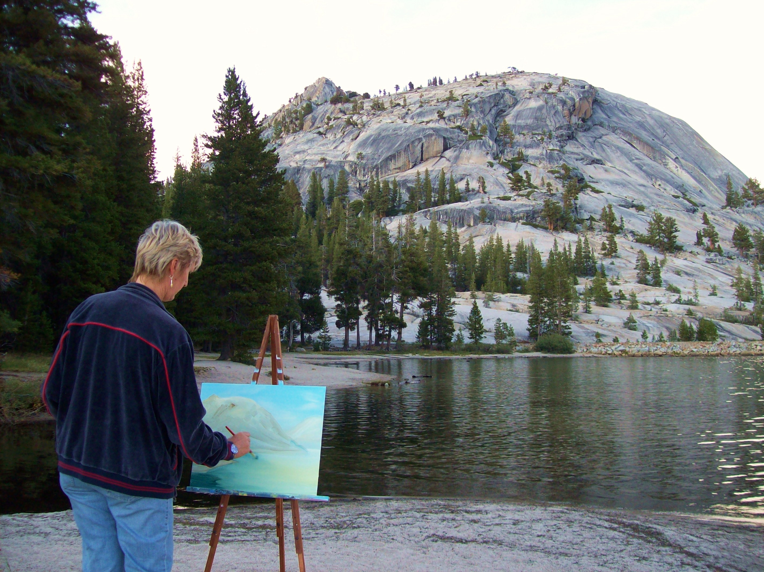

Capturing the “places, faces and homes of America on camera and on canvas”, Yosemite National Park was one of the highlights of the Across the USA from the Eyes of an Artist tour and the subject of an open air painting session on the shores of Lake Tanyere. The journey marks the re-emergence of visual artist Leisa Collins into the art world after two decades of global travels and social activism.

Heading out of Los Angeles 10 days ago, the tour first traveled to the Grand Canyon and in now heading back through California before moving up the coast and advancing east. Culminating in New York near the end of September, the USA tour has traveled 2,000 miles to date, with another 4,000 more to go.

“I have traveled all over the world but I was extremely impressed with how user-friendly the Yosemite National Park is. The roads, public facilities, campgrounds and trails are well maintained and clearly sign posted. Add to this breath taking views every few minutes, crystal clear lakes and unique colossal mountain domes and you have a real winner!” said Collins.

As the setting sun was beginning to turn the mountain tops on the shores of Tenaya Lake a golden yellow, Collins couldn’t resist getting out her easel and “setting up shop”. She painted the basic form of the scene and took photos before having to postpone the session due to lack of light.

Collins’ focus today is on promoting art for change. She first launched her artistic career in New Zealand 1976, after she abandoned formal art training and opted to learn her craft by capturing the beauty of the New Zealand wilderness on her canvas.

In addition to recording the scenic beauty and people of of America through photos and paintings created by Collins on the road and promoted through her Art with a Message Blog. She also has art projects scheduled along the tour route to promote and raise funds for children and art education. In this regard, Collins is partnered with Free Arts for Abused Children so as to get this message across.

Collins is now headed up the coast via the Redwood National Park. She will stop off in Seattle, Washington, Yellowstone National Park and the Badlands in South Dekota, then Sioux Falls City, Minneapolis/St Paul in Minnesota, Green Bay and Milwaukee in Wisconsin. Crossing to Illinois they will visit Chicago and move onto Lansing and Detroit in Michigan. Following will be the Niagara Falls and the Pennsylvania cities of Pittsburgh and Philadelphia before they reach their final destination of New York City.

A native of New Zealand, but international in scope, Collins is now combining her activist and artistic skills under the motto of art with a message. Working mainly in acrylic and watercolors, Collins is diverse, painting landscapes one day and house portraits and face portraits the next. She also works with other women artists and specializes in art for change projects; in both the realistic and semi-abstract genres. You will find the USA tour route under the Art in Action page of her website. www.leisacollins.com and her Art with a Message Blog, www.leisacollinsartwithamessage.blogspot.com, follows the action of the tour. Sign up for her weekly newsletter, Art in the Making from her website.

